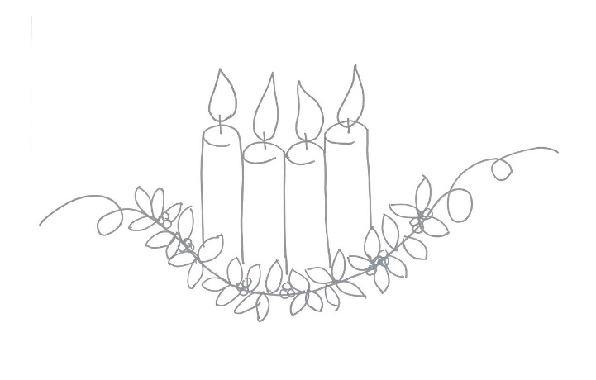
As we enter the season of Advent, I hope that you can take the time and focus on quality rather than quantity. It’s a great feeling to be invited to all of the Christmas parties, but at some point, they all blur together and it becomes an exhausting holiday experience. Advent should be a time to ‘reset’ ourselves. In previous years, I’ve found myself longing for a vacation after the Christmas season – a sure sign I was trying to ‘do all the things!’
In recent years, and again this year I plan on taking the time to enjoy the time spent with friends and family. If I don’t get all the Christmas cards out, it’s ok. If I don’t get around to any baking, or only manage to bake one kind of cookie this year instead of the thirteen different types of cookies as I have in years past (with and without nuts, chocolate and no chocolate, one of each for everyone I’m gifting to unless they have allergies, then more of the ones they aren’t allergic to. It really was quite the process!) While I enjoy giving gifts to people, it really isn’t necessary to go to the extent I have in the past. And that’s ok.
On our website, we have a page titled Advent and Christmas. I hope you will take the time to look at some of the ideas we’ve put together for you. Better yet, consider attending one of our events and inviting someone to come with you. Personally, I’m going to look at signing up for ONE of the Daily Reflections to be sent to my inbox. My Advent resolution is to actually take the time and read/watch daily in the hope that I will have a more spiritual Christmas this year.
“Insignificant man, escape from your everyday business for a short while. Hide for a moment from your restless thoughts. Break off from your cares and troubles and be less concerned about your tasks and labors. Make a little time for God, and rest a while in him.” - St. Anselm

Wishing you and yours a healthy and happy season,
Jen Lonergan
Administrative Assistant for Holy Trinity & Historic St Patrick

